**Lost in Space UML DESIGN**

**Table of Contents**

1. **Context Diagram ………………………………………………. 3**
2. **Big Picture ………………………………………………. 4**
3. **AI ………………………………………………. 5**
4. **Ships ………………………………………………. 6**
5. **Canvas ………………………………………………. 7**
6. **Score ………………………………………………. 8**
7. **Controls ………………………………………………. 9**
8. **Debris ………………………………………………. 10**
9. **Save ………………………………………………. 11**

**Context Diagram**

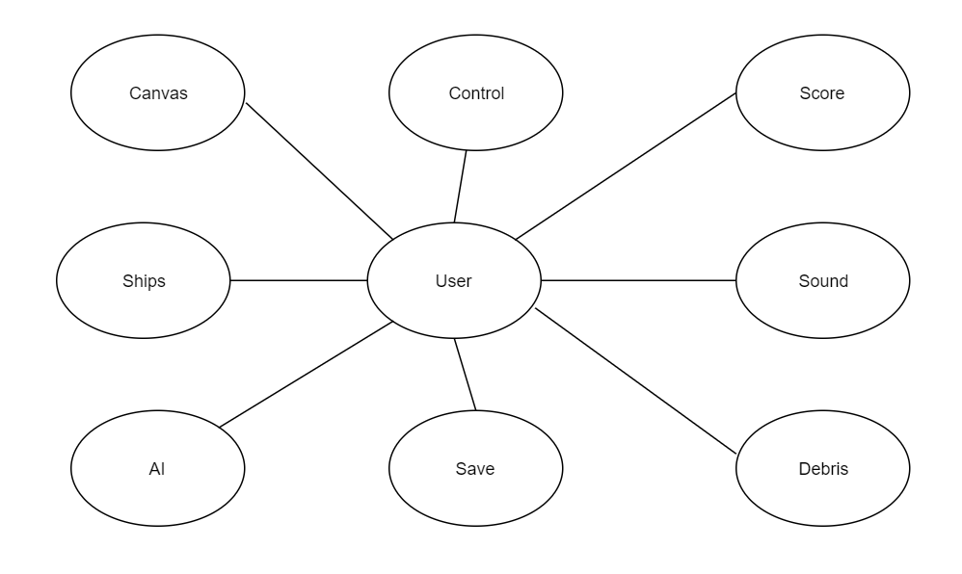

**UML-Class Diagram-Big Picture**

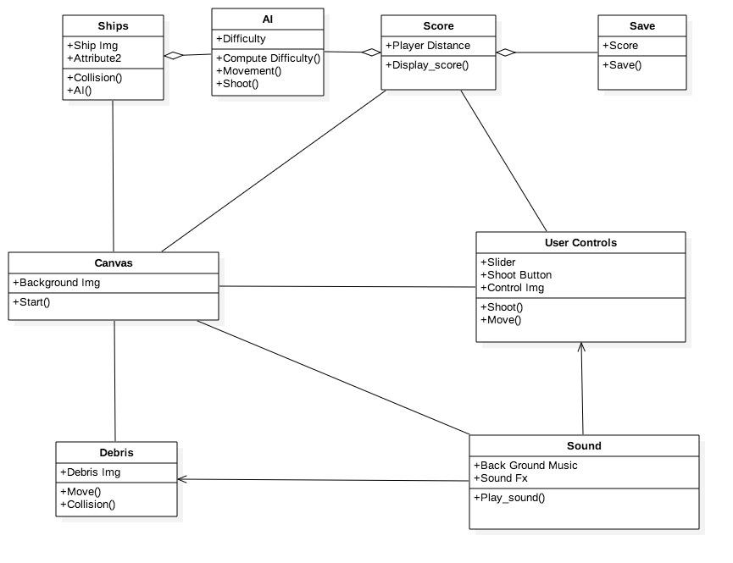

**UML-Transition Diagram-AI**

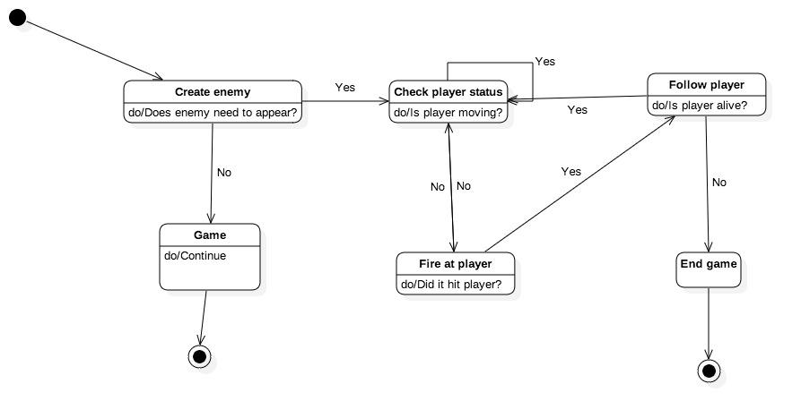

**UML-Sequence Diagram-Ships**

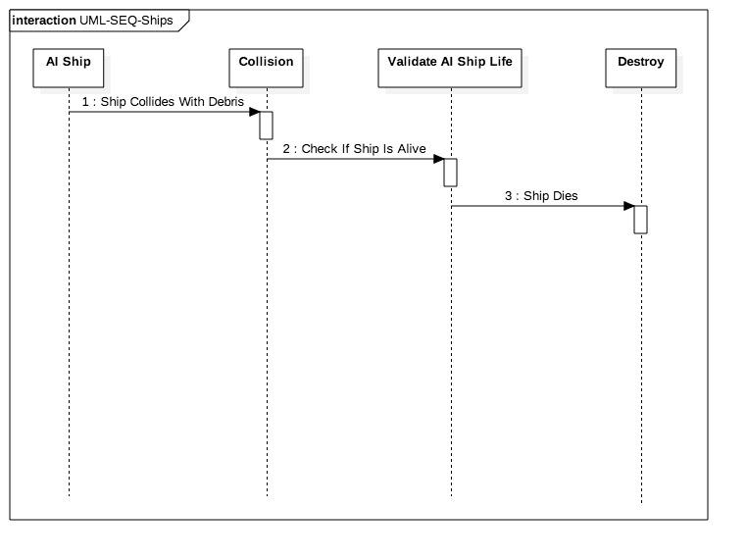

**UML-Sequence Diagram-Canvas**

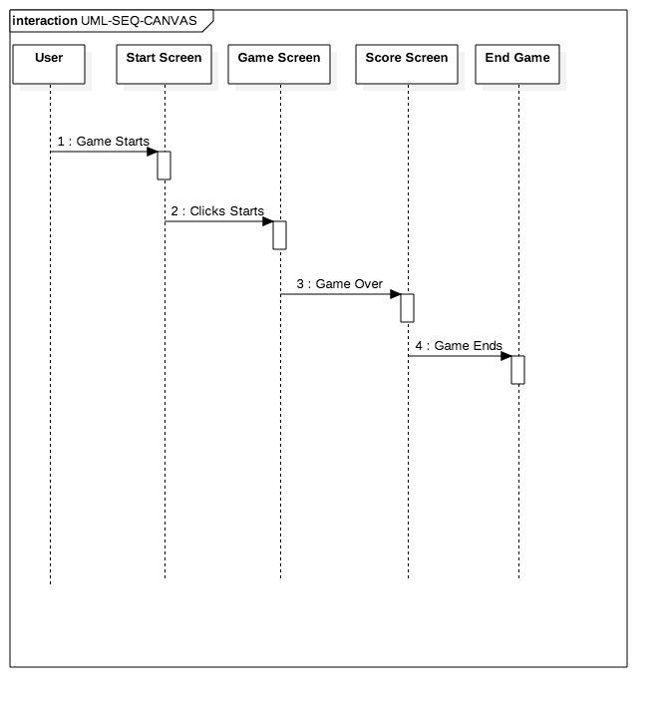

**UML-Sequence Diagram-Score**

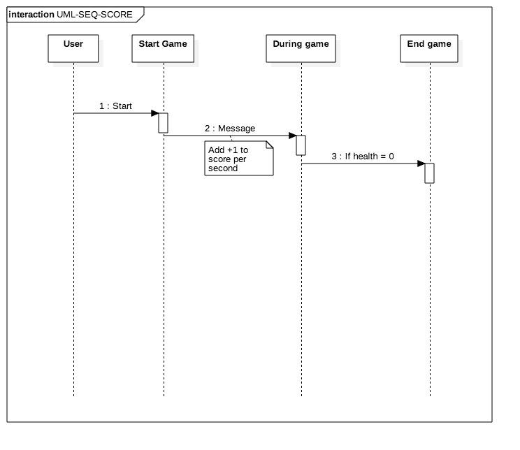

**UML-Class Diagram-Controls**

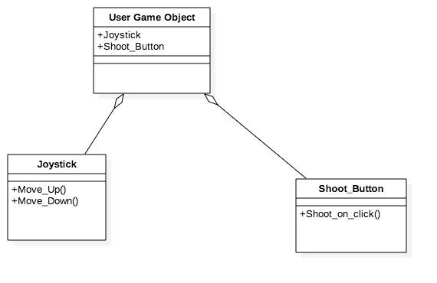

**UML-Activity Diagram-Debris**

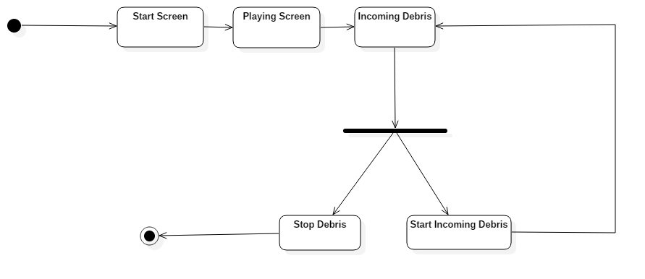

**UML-Sequence Diagram-Save**

